**CASE STUDY- RESOLVING MERGE CONFLICTS**

**Problem Statement:**

You work for Zendrix Software & Co. You have been assigned the task of updating

the Master branch of their Git repository with all the features from the feature

branches.

Following is the GitHub account, https://github.com/devops-intellipaat/merge-conflict.git

Consider,

• Feature1 branch to be a public branch

• Feature2 branch to be a private branch

The company relies on a monolithic architecture, and for now all the code resides in one file

“main.c”.

The respective features have been added in the feature branches for main.c.

Meanwhile, a security patch was made to the master branch, and now feature1 and

feature2 branches are behind from master by 1 commit.

**Following tasks have to be done:**

1. Update Feature1 and Feature2 branch with the Security Patch

2. Apply changes of Feature1 and Feature2 branch on master

3. Finally push all the branches to GitHub

For Solving this, please fork the repository to your Github account and then work.

As a solution, please submit your GitHub’s repository link.

Forking the repo https://github.com/devops-intellipaat/merge-conflict.git

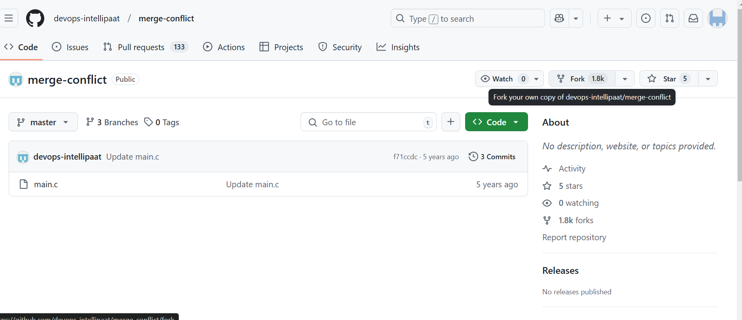

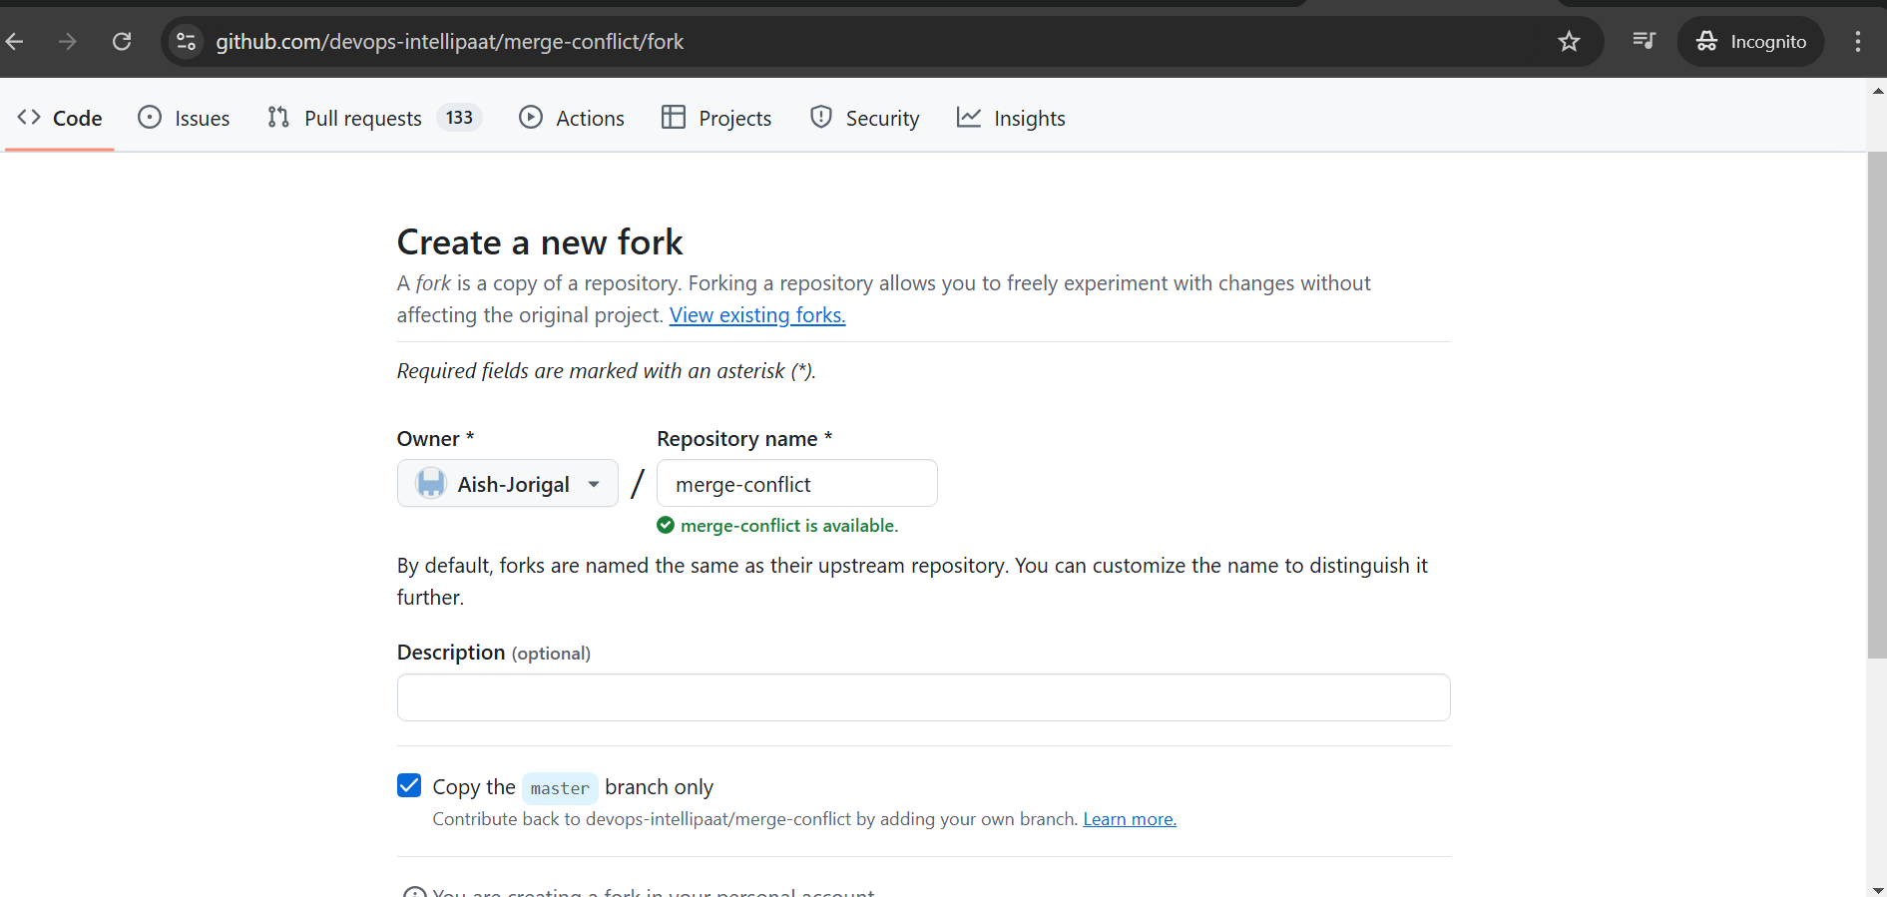

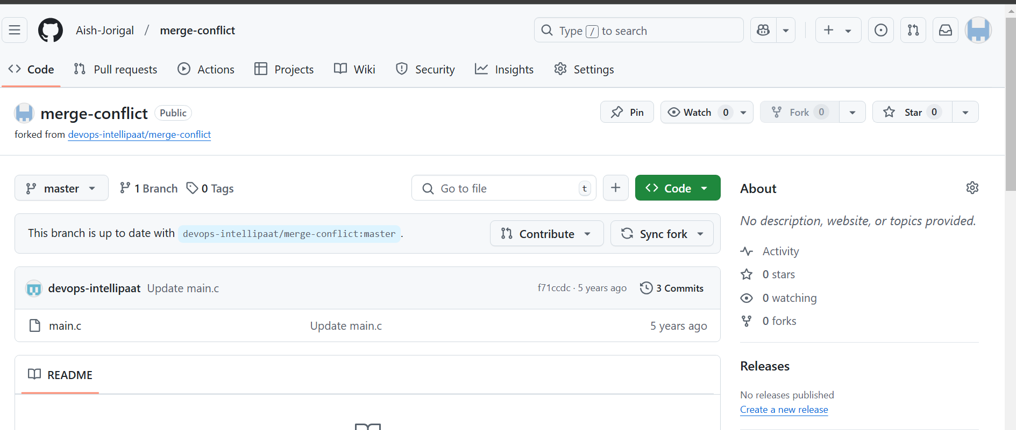

Now clone to local repository

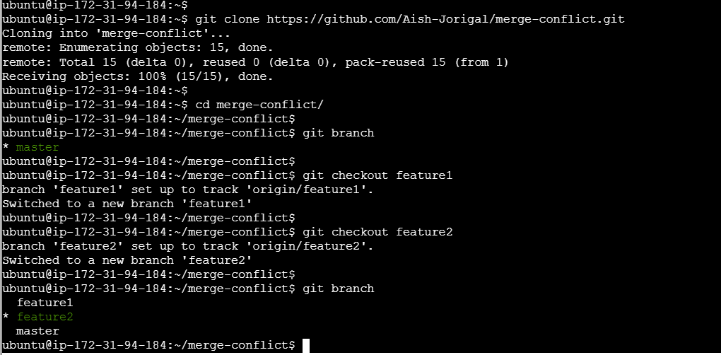

Now merge feature1 to master

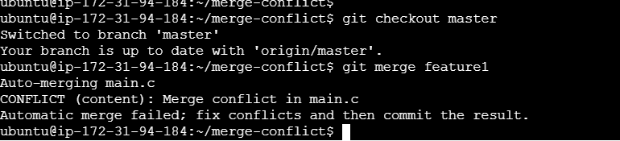

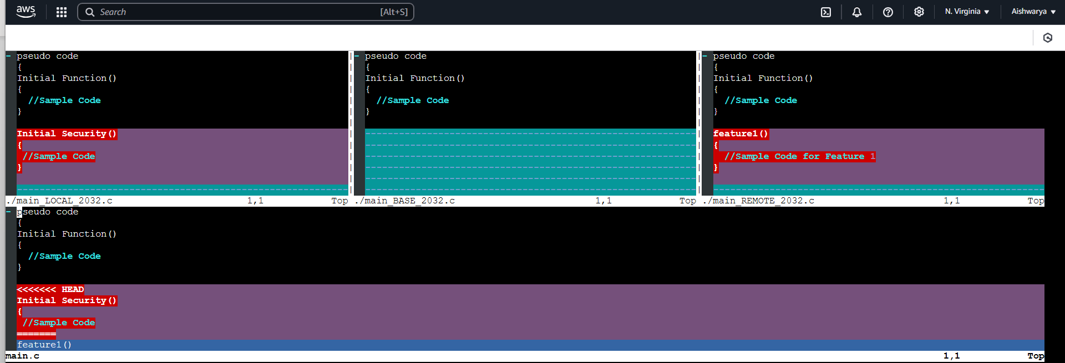

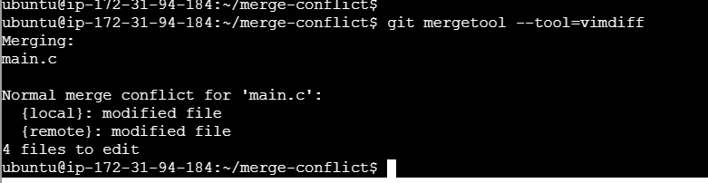

Now merge feature2 to master branch.

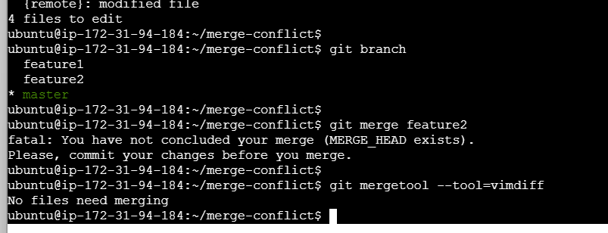

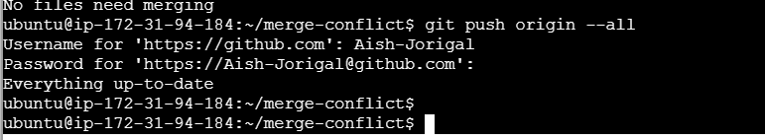

My GitHub link-- https://github.com/Aish-Jorigal/merge-conflict